**Express and handlebars**

Install the required files in terminal first and store them in vs code in a variable

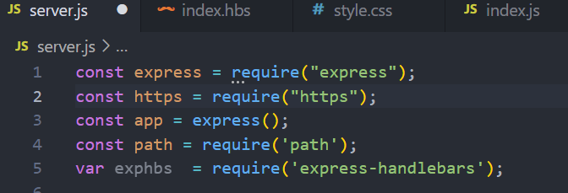

**To send html file css and its corresponding js use public folder and store all files there**

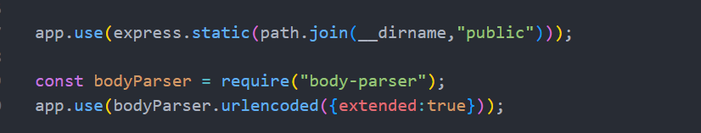

**Use body parser to access the elements**

**Now since we cant edit html using backend server we have to make a new folder named views and make a file there called index.hbs and copy all the content from index.html to index.hbs and delete the index.html file**

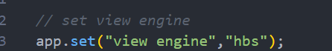

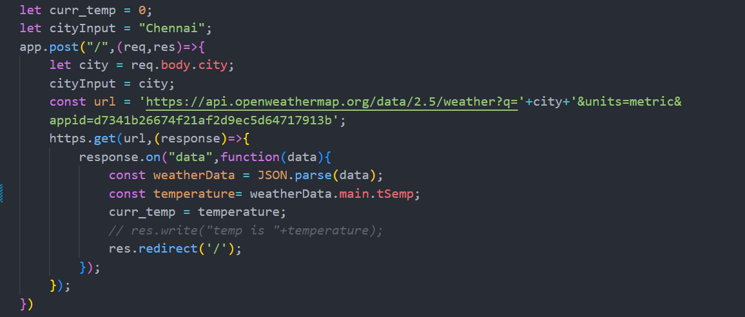

**Use the redirect method to remain on same page(reload)**

**This is how we can change the html**

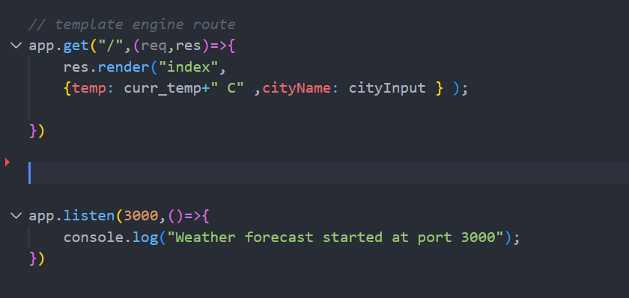

**Index .hbs**

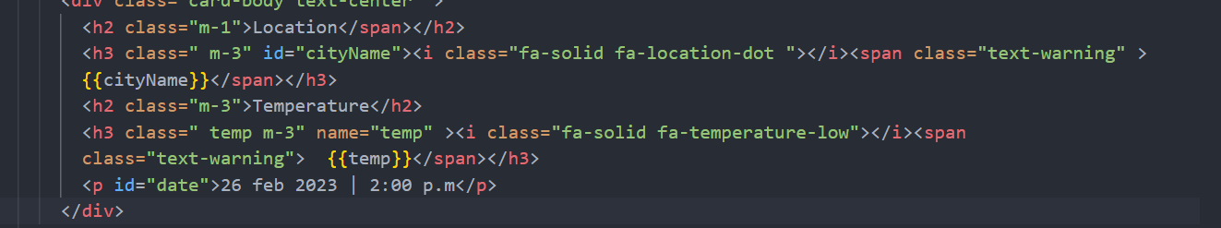

**Jo change karna hai usko {{}} brackets me ek variable me assign kardo aur phir server.js me jake usme assign kardo**